A PROJECT REPORT

**"FOOD QUALITY MONITORING SYSTEM ”**

**UNDER THE GUIDANCE OF**

PROF. SHEETAL WAGHCHAWARE

**SUBMITTED BY**

MANGESH SHINDE

ONKAR CHOUGALE

SANKET RAJGUDE

**IN PARTIAL FULFILLMENT OF THE REQUIREMENTS**

**FOR THE DEGREE OF**

**BACHELOR OF ENGINEERING**



**DEPARTMENT OF**

**ELECTRONICS AND TELECOMMUNICATION ENGINEERING**

**SHALAKA FOUNDATION**

**KEYSTONE SCHOOL OF ENGINEERING**

**(2019-2020)**



**SHALAKA FOUNDATION'S**

**KEYSTONE SCHOOL OF ENGINEERING**

**CERTIFICATE**

**This is to certify that Project entitles**

**"FOOD QUALITY MONITORING SYSTEM ”**

**SUBMITTED BY**

**MANGESH SHINDE**

**ONKAR CHOUGALE**

**SANKET RAJGUDE**

Is a record of the bonafide work carried out under the supervision of Prof. Sheetal Waghchaware and is approved as the partial fulfillment of the requirement for the award of degree in Electronics and telecommunication engineering of the University of Pune

**__________________ _________________ ______________**

**Prof. Sheetal Waghchaware Prof. R. A. Barapate Principle**

**Guide Head of Department**

**Department of E&TC Department of E&TC**

**Place: Pune Date:**

# **ABSTRACT**

Food plays a very important role in our day to day life. With an increase in globalization quality of food decreases day by day. In most of the time various food processing is done to keep the food fresh. Various preservatives or the ingredients are added in the food so that it looks like fresh or tempting. Now most of the food is preserved with the chemicals which causes the food contamination. This contamination leads to various diseases which results that the consumer want healthy food. The people wants organic food for healthy lifestyle. So to avoid the problems associated with the food without human interpretation we need such a device which helps to determine the quality of food. There is a requirement of such a device which guide us about the hygienic food. Hence to fulfill this consumer demand we made a device that checks whether the quality of food is good or bad. This paper represents the use of various sensors in the field of the food industry. The sensors like pH sensor, gas sensor, temperature sensor help in identifying the condition of food. This system makes an effective presence in restaurants, households, small scale industries.

**ACKNOWLEDGMENT**

Every orientation work has an imprint of many people and it becomes duty of author to express deep gratitude for the same.

We would like to take this opportunity to express true sense of gratitude towards our project guide **Prof. Sheetal Waghchaware** for her valuable co-operation and guidance that gave us for this project.

We would also like to thank our head of the department **Prof. R. A. Barapate** for inspiring us and providing us all lab facilities with internet, which helped us with the project work.

We would also like to express our appreciation and thanks to all those who knowingly or unknowingly have assisted us & encouraged us for our project.

**INDEX**

|  |  |  |
| --- | --- | --- |
| Sr. No**.** | Content | Page No**.** |
| 1 | Introduction | 7 |
| 2 | Specification | 8 |
| 3 | Block Diagram | 12 |
| 4 | Circuit Diagram | 13 |
| 5 | Simulation | 14 |
| 6 | Arduino Code | 15 |
| 7 | Advantages And Applications | 22 |
| 8 | Future Scope | 23 |
| 9 | Conclusion | 24 |
| 10 | Reference | 25 |
| 11 | Data-sheet | 26 |

**CHAPTER NO. 1**

1.**INTRODUCTION**

A food contamination can occur in the production process, but also a large part caused by the inefficient food handling because of inappropriate ambient conditions when the food is being transported and stored. There are many factors leading to food poisoning, typically changes in temperature and humidity are important factors. So the monitoring system capable of measuring temperature and humidity variability during transport and storage is of prime importance. Today almost everybody is getting effected by the food they consume, it's not only about the junk food, but all the packed foods, vegetables, products consumed and used in daily life, as all of them do not offer quality since their temperature, moisture, oxygen content vary from time to time. Majority of consumers only pay attention to the information provided on the packaging, i.e., the amount of ingredients used and their nutritional value, but they forget that they are blindly risking their health by ignoring the environmental conditions to which these packets are subjected

Every product making firm just want to attract more and more costumers towards them. Their main motive is to sell the product anyhow, like by adding more flavors, coloring chemicals and preservatives to increase the taste and appearance, but they forget that these money making tactics are actually affecting the consumer’s health. To ensure food safety, it should be monitored at every stage of supply chain. It serves the purpose of preventive consumer health protection by maintaining the required standard ambient conditions needed to preserve the quality of food. The performance and analysis of routine measurements, aimed at detecting changes in the nutritional or health status of the food doesn't guarantee.

**CHAPTER NO.2**

**SPECIFICATIONS**

**4.1 Hardware**

Arduino Uno

MQ3 Sensor

LCD 16X2

DHT11 Sensor

LDR[Light Dependent Resistor]

**SPECIFICATIONS**

**1.Arduino Uno:**

Arduino Uno is a microcontroller board based on the ATmega328P (datasheet). It has 14 digital input/output pins (of which 6 can be used as PWM outputs), 6 analog inputs, a 16 MHz quartz crystal, a USB connection, a power jack, an ICSP header and a reset button. It contains everything needed to support the microcontroller; simply connect it to a computer with a USB cable or power it with an AC-to-DC adapter or battery to get started. You can tinker with your UNO without worrying too much about doing something wrong. The worst case scenario is that you would have to replace the chip and start again.

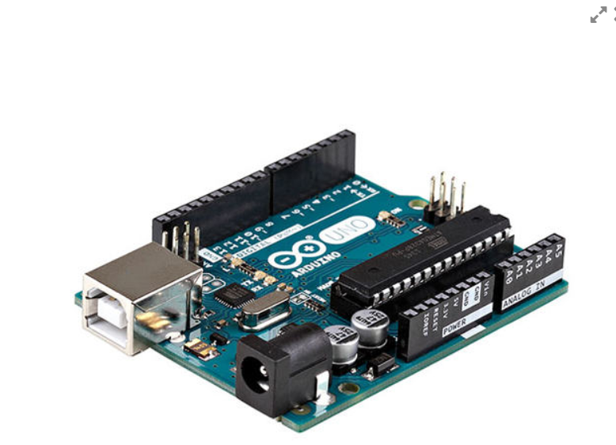

**2.MQ135 Gas Sensor**

MQ-135 Sensor Features

1. Wide detecting scope

2. Fast response and High sensitivity

3. Stable and long life

4. Operating Voltage is +5V

5. Detect/Measure NH3, NOx, alcohol, Benzene, smoke, CO2, etc.

6. Analog output voltage: 0V to 5V

7. Digital output voltage: 0V or 5V (TTL Logic)

8. Preheat duration 20 seconds

9. Can be used as a Digital or analog sensor

10. The Sensitivity of Digital pin can be varied using the potentiometer

Fig: LCD Display (16x2)

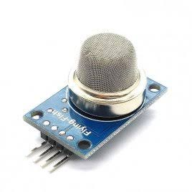

Fig. MQ135 Gas sensor

**3. Liquid Crystal Display (LCD)**

LCD screen is an electronic display. This is used which displays the status of the system. A 16x2 LCD display is very basic module that has 2 controller with 16 pin which is very commonly used in various devices and circuits.

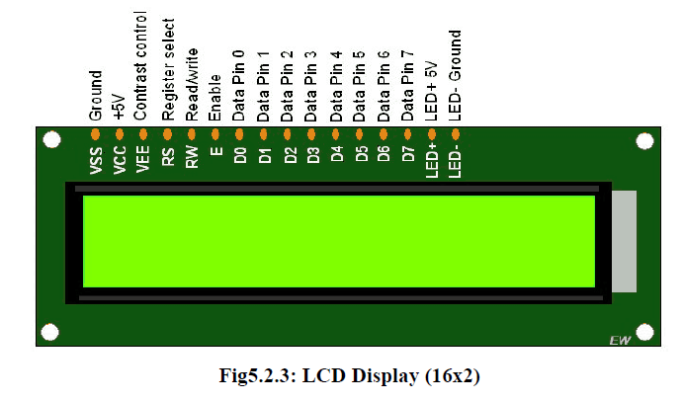

1. **DHT11 Sensor**

The **DHT11**is a commonly used **Temperature and humidity sensor that** comes with a dedicated NTC to measure temperature and an 8-bit microcontroller to output the values of temperature and humidity as serial data.

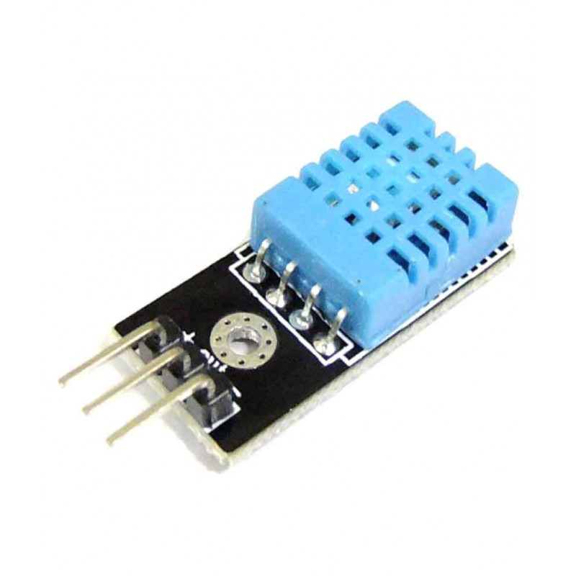

1. **LDR ( Light Dependent Resistor )**

The **Light Dependent Resistor** (**LDR**) or also popularly known as Photoresistor is just another special type of Resistor and hence has no polarity so they can be connected in any direction. They are breadboard friendly and can be easily used on a perf board also. The symbol for LDR is similar to Resistor but includes inward arrows as shown above in the LDR pinout diagram. The arrows indicate the light signals.

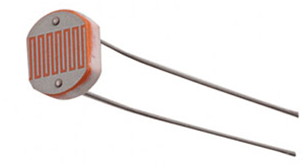

**CHAPTER NO.3**

**BLOCK DIAGRAM**

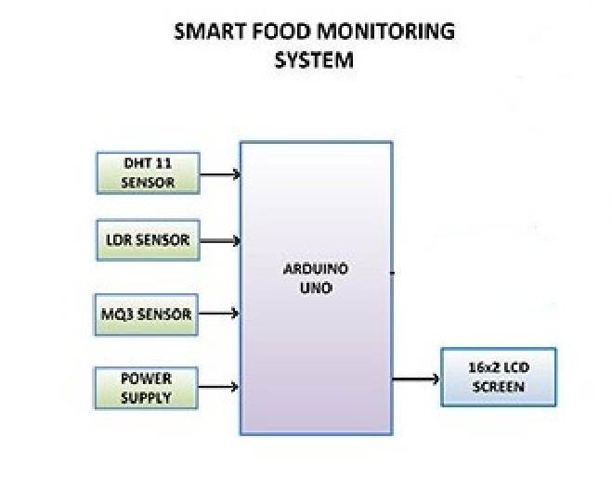

**CHAPTER NO.4**

**CIRCUIT DIAGRAM**

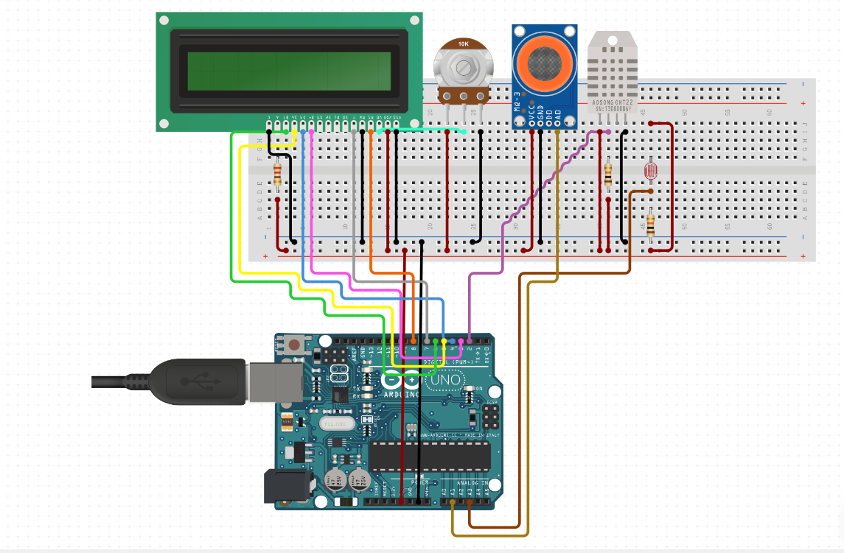

**CHAPTER NO. 5**

**SIMULATION**

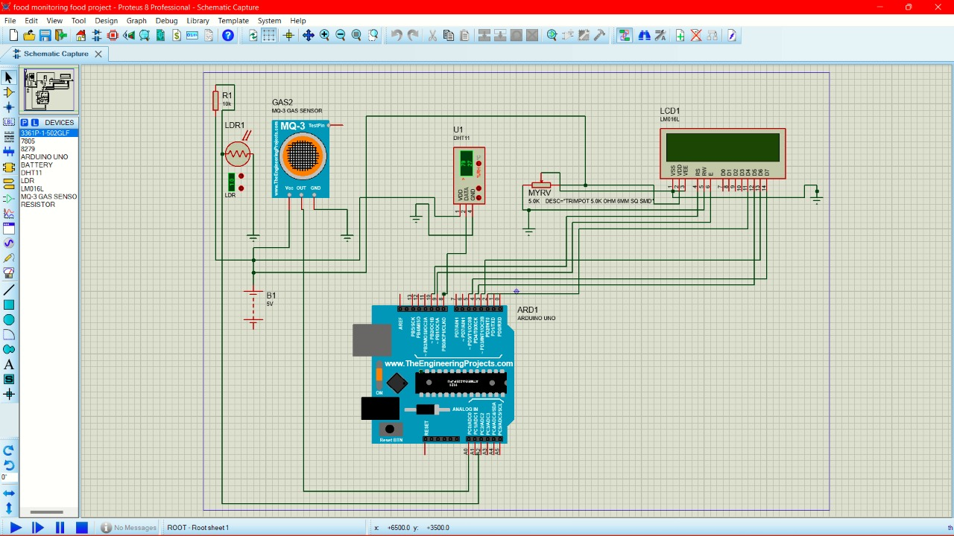

**CHAPTER NO. 6**

**ARDUINO CODE**

**#include <LiquidCrystal.h>**

**#include <dht.h> // include dht sensor library**

**LiquidCrystal lcd(8, 7, 3, 4, 5, 6);**

**dht DHT;**

**float t=0;**

**float h=0;**

**#define DHT11_PIN 2**

**#define LDR_PIN A3**

**#define MQ3_PIN A1**

**char data = 0;**

**int ldr_read = 0;**

**int gas_read = 0;**

**const int ledPin=12;**

**void setup()**

**{**

**pinMode(ledPin, OUTPUT);**

**lcd.begin(16,2);**

**lcd.setCursor(1,0);**

**lcd.print(" --WELCOME TO--");**

**lcd.setCursor(0,1);**

**lcd.print(" -FOOD MONITOR-");**

**Serial.begin(9600);**

**delay(5000);**

**}**

**void loop()**

**{**

**lcd.clear();**

**ldr_read = analogRead(LDR_PIN);**

**Serial.print("Light-");**

**Serial.println(ldr_read);**

**ldr_read=ldr_read-50;**

**if(ldr_read>=100)**

**{**

**ldr_read=100;**

**}**

**lcd.setCursor(0,0);**

**lcd.print("L.E-");**

**lcd.setCursor(4,0);**

**lcd.print(ldr_read);**

**lcd.setCursor(0,1);**

**lcd.print("GAS-");**

**gas_read = analogRead(MQ3_PIN);**

**Serial.print("Gas = ");**

**Serial.println(gas_read);**

**gas_read = gas_read-70;**

**int gas1=gas_read;**

**if(gas_read >=100)**

**{**

**gas_read=100;**

**}**

**lcd.setCursor(4,1);**

**lcd.print(gas_read);**

**int chk = DHT.read11(DHT11_PIN);**

**Serial.print("Temperature = ");**

**t = DHT.temperature;**

**//lcd.clear();**

**lcd.setCursor(8,0);**

**lcd.print("Tem-");**

**lcd.setCursor(12,0);**

**lcd.print(t);**

**Serial.println(t);**

**Serial.print("Humidity = ");**

**h = DHT.humidity;**

**lcd.setCursor(8,1);**

**lcd.print("Hum-");**

**lcd.setCursor(12,1);**

**lcd.print(h);**

**Serial.println(h);**

**delay(3000);**

**if(gas_read>=100)**

**{**

**digitalWrite(ledPin, HIGH);**

**lcd.clear();**

**lcd.setCursor(0,0);**

**lcd.print("Bad FOOD Conditn");**

**lcd.setCursor(4,1);**

**lcd.print("Gas-");**

**lcd.setCursor(8,1);**

**lcd.print(gas_read);**

**delay(2000);**

**}**

**else if(ldr_read>=100){**

**digitalWrite(ledPin, HIGH);**

**lcd.clear();**

**lcd.setCursor(0,0);**

**lcd.print("Bad FOOD Conditn");**

**lcd.setCursor(4,1);**

**lcd.print("L.E-");**

**lcd.setCursor(8,1);**

**lcd.print(ldr_read);**

**delay(2000);**

**}**

**else if(t>=45){**

**digitalWrite(ledPin, HIGH);**

**lcd.clear();**

**lcd.setCursor(0,0);**

**lcd.print("Bad FOOD Conditn");**

**lcd.setCursor(4,1);**

**lcd.print("Tem-");**

**lcd.setCursor(8,1);**

**lcd.print(t);**

**delay(2000);**

**}**

**else if(h>=100){**

**digitalWrite(ledPin, HIGH);**

**lcd.clear();**

**lcd.setCursor(0,0);**

**lcd.print("Bad FOOD Conditn");**

**lcd.setCursor(4,1);**

**lcd.print("Hum-");**

**lcd.setCursor(8,1);**

**lcd.print(h);**

**delay(2000);**

**}**

**else{**

**digitalWrite(ledPin, LOW);**

**}**

**delay(2000);**

**}**

**CHAPTER NO. 7**

**ADVANTAGES & APPLICATIONS**

**7.1 ADVANTAGES**

1.Save fruits and vegetables for longer time.2.Maintain hygiene and clean environment.3. Save data into cloud for future analysis.4. Reduce the commercial loss.5 Increase commercial profit.

**7.2 APPLICATIONS**

1.Can use this system in fruits and vegetable shops.2.Can use this system in agriculture farm.3.Can use this system in flower shops.

**CHAPTER NO.8**

**FUTURE SCOPE**

In Future the project can be upgraded in more ways than one.

* Interface more no. of sensors to know detail content of all gases present in air.
* Interface SD Card to store data.
* Interface GPS module to monitor the pollution at exact location and upload on web page for the netizen.

**CHAPTER NO. 9**

**CONCLUSION**

The FOOD MONITORING SYSTEM approach using smart logistics can address the critical needs of reducing food waste, increasing transportation efficiency, and tracking food contamination. The emerging MI-based communications technology appears well suited for local communications in this environment; however, there are several challenges to making the technology work reliably in the highly dense and dynamic environment of real-world logistics operations

**CHAPTER NO. 10**

**REFERENCES**

[1] A Boubrima, W Bechkit, and H Rivano 2017 A new WSN deployment approach for air pollution monitoring, 2017 14th IEEE Annu. Consum. Commun. Netw. Conf. CCNC 2017, pp. 455–460

[2] B Bathiya 2016 Air Pollution Monitoring Using Wireless Sensor Network 2016 IEEE International WIE Conference on Electrical and Computer Engineering (WIECON-ECE) 19- 21 December 2016

[3] A Škraba, A Koložvari, D Kofja , R Stojanovi , V Stanovov, and E Semenkin 2016 Streaming pulse data to the cloud with bluetooth le or NODEMCU ESP8266 2016 5th Mediterr. Conf .Embed. Comput. MECO 2016 - Incl. ECyPS 2016, BIOENG.MED 2016, MECO StudentChall. 2016, pp. 428–431, 2016

[4] K Keshamoni and S Hemanth 2017 Smart gas level monitoring, booking & gas leakage detector over iot Proc. - 7th IEEE Int. Adv. Comput. Conf. IACC 2017, pp. 330–332

[5] D Spirjakin, A M Baranov, and V Sleptsov 2015 Design of smart dust sensor node for combustible gas leakage monitoring Proc. 2015 Fed. Conf. Comput. Sci. Inf. Syst. FedCSIS 2015, vol. 5, pp. 1279–1283, 2015

[6] H Sohal 2016 Area and Power Analysis of Adiabatic 2x1Multiplexer Designon 65nm CMOS Technology ECE

[7] N K Walia, P Kalra, and D Mehrotra 2016 An IOT by information retrieval approach: Smart lights controlled using WiFi Proc. 2016 6th Int. Conf. - Cloud Syst. Big Data Eng. Conflu.2016, pp. 708–712, 2016

[8] M C Budai , Á Lengyel, L Vajda, A Vidács, R Vida, and M Šimek 2015 Monitoring Health Statusof Relatives – ‘ The Smoke in the C himney ’ Approach, pp. 601–606

[9] M Oprea, M Popescu, and S F Mihalache 2016 A Neural Network Based Model for PM 2 . 5 AirPollutant Forecasting International Conference on System Theory, Control and Computing(ICSTCC), October 13-15 vol. 1, no. 2, pp. 776–781, 2016.

[10] M J Gonzales and L D Riek 2013 Co-designing Patient-centered Health Communication Tools

**CHAPTER NO.11**

**DATASHEET**

